**Riphah International University Lahore, Pakistan**



**Riphah School of Computing & Innovation**

### Final Year Project

**PROJECT REPORT (Part-II)**

**BLoved Bidding**

Project ID:

#### Project Team

|  |  |  |  |  |
| --- | --- | --- | --- | --- |
| **Student Name** | **Student ID** | **Program** | **Contact Number** | **Email Address** |
| Muhammad Nasir | 25924 | BSCS | 03420855308 | [25924@students.riphah.edu.pk](mailto:26502@students.riphah.edu.pk) |
|  |  |  |  |  |

**Ms. Ayesha Majid**

Lecturer

**Project Report**

**BLoved-Bidding**

**Change Record**

|  |  |  |  |  |
| --- | --- | --- | --- | --- |
| **Author(s)** | **Version** | **Date** | **Notes** | **Supervisor’s Signature** |
|  |  |  |  |  |
|  |  |  |  |  |
|  |  |  |  |  |
|  |  |  |  |  |
|  |  |  |  |  |
|  |  |  |  |  |
|  |  |  |  |  |
|  |  |  |  |  |
|  |  |  |  |  |
|  |  |  |  |  |

**APPROVAL**

|  |  |
| --- | --- |
| **PROJECT SUPERVISOR** |  |
| Comments: | |
|  | |
| Name: |  |
| Date: | Signature: |

|  |  |
| --- | --- |
| **PROJECT MANAGER** |  |
| Comments: | |
|  | |
| Date: | Signature: |

|  |  |
| --- | --- |
| **HEAD OF THE DEPARTMENT** |  |
| Comments: | |
|  | |
| Date: | Signature: |

### Dedication

This work is dedicated to our parents who have shown love and unconditional support. We also dedicate this work to our supervisor. The most kindhearted person, who has encouraged us, believed in us and has been our support system. Thank you for having faith in us and for helping us through this project.

### Executive Summary

Online marketplaces for preloved and new items, such as OLX.pk, Khazanay.pk, and social media pages, face challenges in maintaining customer trust, ensuring product quality, and providing efficient customer service. Issues include product misrepresentation, difficulties in the return and refund process, and many other problems.

### Acknowledgement

First of all, we are obliged to Allah Almighty the Merciful, the Beneficent and the source of all Knowledge, for granting us the courage and knowledge to complete this Project. We are grateful to our supervisor ***Ms Ayesha Majid*** for placing complete faith and confidence in our ability to carry out this project and for providing us time, inspiration, encouragement, help, valuable guidance, constructive criticism and constant interest. We would also like to thank our family and friends for our continuous support.

**Muhammad Nasir**

**25924**

### Table of Contents

Dedication iv

Acknowledgements v

Executive Summary iv

Table of Contents vi

List of Figures viii

List of Tables viii

Chapter 1 1

Introduction 1

* 1. Background 2
  2. Motivations and Challenges 2
  3. Goals and Objectives 3
  4. Literature Review/Existing Solutions 3
  5. Gap Analysis 3
  6. Proposed Solution 4
  7. Project Plan 5
     1. Work Breakdown Structure 5
     2. Roles & Responsibility Matrix 5
     3. Gantt Chart 5
  8. Report Outline 5

Chapter 2 7

Software Requirement Specifications 7

* 1. Introduction 8
     1. Purpose 8
     2. Document Conventions 8
     3. Intended Audience and Reading Suggestions 8
     4. Product Scope 8
  2. Overall Description 9
     1. Product Perspective 9
     2. Product Functions 9
     3. User Classes and Characteristics 10
     4. Operating Environment 10
     5. Design and Implementation Constraints 10
     6. User Documentation 12
     7. Assumptions and Dependencies 12
  3. External Interface Requirements 12
     1. User Interfaces 12
     2. Hardware Interfaces 12
     3. Software Interfaces 13
     4. Communications Interfaces 13
  4. System Features 13
     1. System Feature 1
        1. Description and Priority **Error! Bookmark not defined.**
        2. Stimulus/Response Sequences **Error! Bookmark not defined.**
        3. Functional Requirements **Error! Bookmark not defined.**
     2. System Feature 2 **Error! Bookmark not defined.**
        1. Description and Priority **Error! Bookmark not defined.**
        2. Stimulus/Response Sequences **Error! Bookmark not defined.**
        3. Functional Requirements **Error! Bookmark not defined.**
     3. System Feature 3 (and so on) **Error! Bookmark not defined.**
  5. Other Nonfunctional Requirements 18
     1. Performance Requirements 18
     2. Safety Requirements 19
     3. Security Requirements 19
     4. Software Quality Attributes 19
     5. Business Rules 20
  6. Other Requirements **Error! Bookmark not defined.**

Chapter 3 21

Use Case Analysis 21

* 1. Use Case Model 22
  2. Fully Dressed Use Cases 23

Chapter 4 29

System Design 29

* 1. Architecture Diagram 31
  2. Domain Model **Error! Bookmark not defined.**
  3. Entity Relationship Diagram with data dictionary 31
  4. Class Diagram 32
  5. Sequence / Collaboration Diagram 33
  6. Operation contracts **Error! Bookmark not defined.**
  7. Activity Diagram 35
  8. State Transition Diagram **Error! Bookmark not defined.**
  9. Component Diagram **Error! Bookmark not defined.**
  10. Deployment Diagram **Error! Bookmark not defined.**
  11. Data Flow diagram [only if structured approach is used - Level 0 and 1] **Error!**

##### Bookmark not defined.

Chapter 5 38

Implementation 38

* 1. Important Flow Control/Pseudo codes 39
  2. Components, Libraries, Web Services and stubs 39
  3. Deployment Environment 39
  4. Tools and Techniques 39
  5. Best Practices / Coding Standards **Error! Bookmark not defined.**
  6. Version Control **Error! Bookmark not defined.**

Appendices **Error! Bookmark not defined.**

Appendix A: Information / Promotional Material **Error! Bookmark not defined.**

Reference and Bibliography **Error! Bookmark not defined.**

Index **Error! Bookmark not defined.**

### List of Figures

* 1. Caption of first figure of first chapter 6
  2. Caption of second figure of first chapter 7
  3. Caption of first figure of second chapter 14
  4. Caption of second figure of second chapter 22
  5. Caption of third figure of second chapter 26
  6. Caption of first figure of fifth chapter 49
  7. Caption of second figure of fifth chapter 49

### List of Tables

* 1. label of first table of first chapter 6
  2. label of second table of first chapter 7
  3. label of first table of second chapter 14
  4. label of second table of second chapter 22
  5. label of third table of second chapter 26
  6. label of first table of fifth chapter 49
  7. label of second table of fifth chapter 49

# Chapter 1

## Introduction

1

**Chapter 1:** Introduction

* 1. BLoved Bidding is an online marketplace for buying and selling pre-loved items. Built with the MERN stack, it allows buyers to browse products, join live auctions, and buy items directly. Sellers can upload products, set auctions, manage orders, and create promotions. Admins oversee users, products, and transactions. The platform ensures fair bidding, secure transactions, and a smooth user experience. With features like

Messaging, reviews, and event creation, BLoved Bidding offers a trusted and competitive alternative for online buying and selling.

### Background

In the rapidly evolving digital age, online marketplaces have become an integral part of the global economy, revolutionizing how consumers and sellers interact. Traditional retail models are increasingly being supplemented, and in some cases replaced, by online platforms that offer greater convenience, wider selection, and often, better prices. However, despite the growth and popularity of these platforms, many still suffer from significant issues such as lack of quality control, inefficient customer service, and insecure payment systems.

In Pakistan, the marketplace landscape is dominated by platforms like OLX.pk and Facebook Marketplace, which, while popular, often leave users frustrated due to these deficiencies. Buyers face challenges like unverified product listings, misleading descriptions, and a lack of recourse in case of disputes. Sellers, on the other hand, struggle with gaining trust and visibility among potential buyers.

Recognizing these gaps, we aim to create "BLoved Bidding" a curated online marketplace dedicated to preloved items such as clothing, shoes, Wedding Cloth, and Furniture. Our goal is to bridge the gap between quality and convenience, ensuring that each transaction is secure, transparent, and satisfactory. By implementing rigorous product verification processes, fostering clear communication channels, and providing secure payment options, BLoved Bidding aspires to set a new standard in Pakistan's online marketplace industry, promoting sustainable shopping while delivering an exceptional user experience.

### Motivations and Challenges

The motivation for doing this project was primarily an interest in undertaking a challenging project, learning new things and also something which has a scope at the same time. The opportunity to learn about a new area of computing not covered in lectures was appealing. This is possibly an area that we look forward in the future. Secondly, we thought it has been quite a while that we have been working on the same management systems, it would be better to move on and try something new and challenging. It would be a challenge

working with the new frameworks that we never even heard of previously as it will take time learning them and then working on them.

### Goals and Objectives

* Be the leading curated online marketplace for preloved items in Pakistan.
* Promote sustainable shopping and extend the life cycle of quality goods.
* Offer a diverse selection of preloved clothing, shoes, accessories, and homeware.
* Ensure a high standard of quality through curation and clear product descriptions.
* Build a user-friendly platform for effortless buying and selling.
* Provide secure payment options and clear communication channels.
* Foster trust and transparency with seller profiles and buyer reviews.
* Attract a critical mass of engaged buyers and sellers to create a vibrant marketplace.
* Achieve profitability through a sustainable business model.
* Become a socially responsible company, promoting environmental consciousness.

### Literature Review/Existing Solutions

|  |  |  |  |  |
| --- | --- | --- | --- | --- |
| **Feature** | **BLoved Bidding** | **[OLX.pk](http://olx.pk/)** | **[Khazanay.pk](http://khazanay.pk/)** | **Facebook Marketplace** |
| **Focus** | Preloved items (clothing, shoes, accessories,  wedding furniture) | All categories (new & preloved) | All categories (new & preloved) | All categories (new & preloved) |
| **Target Audience** | Broad - Sustainable shoppers, budget- conscious, vintage  enthusiasts, Bulk buyers | General audience | General audience | General audience |
| **Curation** | Yes - Focus on quality and variety | No - Buyer beware | No - Buyer beware | No - Buyer beware |
| **User Interface** | Emphasis on user- friendliness and smooth  experience | Varied experience depending on seller | Varied experience depending on seller | Varied experience depending on seller |
| **Communication** | Clear communication channels within platform | Limited communication tools | Limited communication tools | Primarily relies on Facebook messenger |
| **Seller Profiles** | Yes - Builds trust and transparency | No | Limited seller information | No seller profiles |
| **Buyer Reviews** | Yes - Builds trust and transparency | No | Limited buyer reviews | No buyer reviews |
| **Rating Seller** | Yes | No | No | No |
| **Buyer Feedback** | Yes | No | No | No |
| **Bidding** | Yes | No | No | No |

* 1. **Gap Analysis**

Existing marketplaces often lack focus on quality curation, user-friendly interfaces, and secure transactions. BLoved bridges this gap by offering a meticulously curated selection of preloved treasures across fashion homeware, and accessories. Our user-friendly platform streamlines buying and selling, while secure payment options and seller profiles with buyer reviews ensure trust and transparency. By addressing these shortcomings and fostering a community around preloved items, BLoved bidding to become the leading curated online marketplace for sustainable shopping in Pakistan.

### Proposed Solution

**Product Authenticity and Quality Control**: Establish a rigorous verification process for product listings to ensure authenticity and condition, addressing concerns similar to those faced by Khazanay.pk customers.

**Efficient Customer Service**: Develop a responsive customer support system to handle inquiries and complaints promptly, improving upon the customer service issues reported by Khazanay.pk users.

**Streamlined Return and Refund Process**: Create a clear and user-friendly return policy, addressing the refund issues experienced by Khazanay.pk customers.

**Secure Payment Gateway**: Implement a reliable and secure payment system to avoid the payment issues encountered on OLX.pk.

**Social Media Engagement**: Leverage social media platforms for marketing and customer engagement, turning the challenge of competing with Facebook and Instagram pages into an opportunity for growth.

**User Reviews and Feedback**: Encourage user reviews and ratings to build trust and provide social proof, similar

to the positive feedback seen on Khazanay.pk’s website.

By addressing these issues with the proposed solutions, your website can offer a reliable and satisfying experience for customers looking to purchase preloved items online.

### Project Plan

* + 1. **Work Breakdown Structure**

Documentation...

ActivityandERD...

ArchitectureDiagram ...

AnalysisandSearch...

Create Projectand P...

SequenceDiagram...

InternetResearch...

WhiteBoxTesting...

UpdateFunctionalty...

DevelopmentSystem...

ClassDiagram...

CunductSurvey...

MarketingResearch...

UpdateDocumentation...

Control Flow...

UsecaseDiagram...

Developer Survey...

ProjectScope and Go...

Testing...

BlackBoxTesting...

Modificationand Upd...

Implimentation...

Design...

RequirementGatherin...

PlanningPhase...

BLovedBidding

* + 1. **Roles & Responsibility Matrix**
    2. **Gantt Chart**

### Report Outline

For clarity and understanding, this report is divided into chapters.

**Chapter 1:** Introduction

The primary focus of the first chapter is to describe the project in detail. State the motivations, challenges, objectives and goals.

**Chapter 2:** Literature Review

The second chapter gives an overview of the literature and technologies.

**Chapter 3:** Requirement Analysis

The primary focus of this chapter is to state the problem that leads to the development of the project, also functional and non-functional requirements of the project.

**Chapter 4:** System Design

This chapter covers the architectural design and detailed designs of the project.

**Chapter 5:** Implementation

This chapter states the best practices or the coding standards followed. It also explains a flow chart diagram or pseudo code.

# Chapter 2

## Software Requirement Specifications

**Chapter 2:** Software Requirement Specifications

### Introduction

Connect Customer’s and Seller’s for fast, easy and affordable dealing. We are trying to build a web application in which we connect the customer and the seller directly without any third person in which the customer can do bidding against the product with the seller.

#### Purpose

We aim to make the customer easily connect the seller or company directly without any third person so that the customer can easily bid for the product in which he/she is interested to buy. This website has been developed to provide online service. You can find your product and also compare the price and rating of the product from different sellers so that you can easily choose the best product. In this application customers can easily contact the seller through phone number or by message. We try to provide an online service tailored to your needs. Anyone will be able to use it.

#### Document Conventions

In the document conventions session, we will discuss our FYP synopsis roles and regulation that we are following during writing this document.

First of all, in this document, we divided all text into four types. These are described below.

* + - * Heading1
      * Heading2
      * Paragraph
      * Figures

#### Intended Audience and Reading Suggestions

We are mainly focusing on targeting the audience related to this website. Our main audience is all the customers who want to buy the products in bulk or at wholesale price. In this pandemic time, people are not able to go out and we will propose an online system for which the customer can buy the product at bulk and wholesale price. This will make it easy for them and on the other hand, it also allows the user (customer) to deal with the seller or company without any third person.

#### Product Scope

Our main idea is that it will help all the people to directly deal with the seller without any third person or wait for the person to come to take the order. The customer can now find the required product and also compare the product with the other sellers and deal with the seller with high rating and having good

reviews and also can bid for the product with the seller. We will develop such a system in which customers can easily find multiple sellers from different companies on the same platform. We are providing services all over Pakistan but the major cities of Pakistan like Lahore, Karachi, Faisalabad, Islamabad are our main focus. We are trying to provide a platform easy on the eyes and easy to use. Our seller/company are verified and they know what to do and we provide the phone number of the seller/company for any disturbance or any problem. It will be time saving and efficient.

Customers can find the product at the cheapest price and directly from the seller/companyonline. We provide fully guaranteed and verified products. People will find it easy to order products and take full advantage of it.

### Overall Description

#### Product Perspective

Finding a reliable and affordable product from the verified seller is a time taking task and it takes a lot of time. Don’t worry, we can help you with it. From booking the product we ensure an efficient and agile procedure.

##### Satisfaction & Guaranteed:

We provide you the guaranteed products and our sellers are guaranteed and verified. Our seller will make you satisfied with their product and services.

#### Satisfaction & Guaranteed:

We provide you the guaranteed products and our sellers are guaranteed and verified. Our seller will make you satisfied with their product and services.

#### Product Functions

“One of Our Main Feature Is Provide You A Good Customer Service”

Our services are very fast and reliable. People will not have to wait for a long time for their order. We have a verified seller or company. You want to contact the admin or we have made a contact us page in which you enter your E-mail address and also write a text message for the admin and the customer support. If you add your leads requirement and the product is available at any seller then the seller received the notification for the lead or if the seller accepts the lead then the chat against the deal will start. You can search different products of different categories from different sellers on our website according to your needs and also check the rating of the product for the best deal.

We don’t have any hidden or extra charges.

As you are fully aware of today’s situation, most of the customers are unable to get the product because the order taker does not come to take the order so we make this product. So that customer does not wait for the product. We try to provide an online service tailored to your needs and it is very efficient. Anyone can easily use it because it is very simple and easy to use. We are providing 100% guaranteed products with no mishaps or any misuse of the information. We seek to connect the customer with the seller directly and book the order without any third person involved. We have added major cities of Pakistan like Lahore, Karachi, Islamabad etc. to provide the service as well.

#### User Classes and Characteristics

This application is for all types of users but for using this application users need to know a little bit about the technicality and also some knowledge about application use.

This application is very easy to use and helpful to educated persons but the uneducated person can also use it after some time of training because this application will be very user-friendly. In case some people or people are not educated and they do not know about technology and they do not use any application before it so it is a little bit difficult for these types of people.

The seller needs a little bit of training before using this application as well. If a seller used this type of software before it so they did not have to worry. But in order to manage the store and know all features of this application they must have to take a small training session to know all about this application for better use.

#### Operating Environment

The operating environment for Beloved Store is as listed below:

* Operating system: Windows 10
* Database: mongoDB
* Platform: Visual Studio 2020.
* Server Based: Our website will be server-based and a local server will be used for it.
* Languages: React, Tailwindcss, JAVASCRIPT, Express nodejs, MongoDB.

**2.2.5. Design and Implementation Constraints**

Our design and Implementation Constraints are as follows:

### Front End:

##### React:

React is a JavaScript library used for building interactive and dynamic user interfaces. It provides a component-based structure, making it easier to develop reusable UI elements and manage application states efficiently.

##### Tailwind CSS:

Tailwind CSS is a utility-first CSS framework that allows developers to design responsive and modern user interfaces quickly. It provides pre-defined utility classes, eliminating the need for writing custom CSS and making styling more efficient.

##### JAVASCRIPT:

JAVASCRIPT is used for client-side scripting which can help in using validation on the website and many more other functions.

#### Express.js & Node.js

Express.js is a lightweight and flexible web framework for Node.js that simplifies building web applications and APIs. It provides powerful features for routing, middleware, and HTTP handling, making it one of the most widely used frameworks for backend development.

Node.js is a JavaScript runtime environment built on Chrome's V8 engine, allowing developers to run JavaScript outside the browser. It is used for server-side development, handling asynchronous operations efficiently, and creating scalable applications.

#### MongoDB:

MongoDB is a popular open-source NoSQL database designed for high performance, scalability, and flexibility. Unlike traditional relational databases, MongoDB stores data in a document-oriented format (JSON/BSON), making it ideal for handling large amounts of unstructured or semi-structured data.

MongoDB was developed by MongoDB Inc. and is distributed under the Server Side Public License (SSPL). It is widely used in modern web applications, big data, real-time analytics, and cloud-based solutions due to its ability to handle large-scale distributed systems efficiently.

#### User Documentation

Our application targets all types of people. In this case every person doesn’t know how to use a web application and get advantages. If a user wants to know and use this application, we will provide them with an application manual or documentation in which we will define all functions and facilities of our application with the help of documentation. Users can understand and use our application easily. But in case the user is not educated and can’t read the documentation, we will provide them with a video tutorial in which we discuss all functionality of our application and how to use it in a better way. With the help of these things, users can easily understand our application workflow and use it.

#### Assumptions and Dependencies

The product needs the following third-party products:

* MongoDB to store databases.
* React to develop the application front view.
* TailwindCSS to design the application front-end.
* Express, Nodejs to make websites more functional.

### External Interface Requirements

#### User Interfaces

The user interface of this application is very user-friendly and attractive. Some of the user interfaces and main layouts we will describe there in the application we will design a simple and attractive site this site will be available for all types of the users. The local people or users can visit this site to find their products.

On the admin side, our application has the main layout page. This page will be inherited with the whole application pages. This page has two sidebars, one contains some features of the website and the other sidebar contains the features of the specific seller.

#### Hardware Interfaces

This application is a web-based application for running this application you need a web browser on your PC and a stable internet connection. The faster the internet speed, the faster the application will work. In web browsers, you need one of them with these hardware specifications like.

### Browsers Hardware

|  |  |
| --- | --- |
| Google Chrome | An Intel Pentium 4 processor or later that's SSE3 capable |
| Mozilla Firefox | Pentium 4 or newer processor that supports SSE2 512MB of  RAM /2GB of RAM for the 64-bit version 200MB of hard drive space |
| Microsoft Edge | 1 gigahertz (GHz) or faster processor or SoC 1 gigabyte (GB)  for 32bit or 2 GB for 64-bit DirectX 9 or later with WDDM 1.0 driver |

#### Software Interfaces

**Operating System:** We have chosen Windows 10 operating system for its best support and user- Friendliness.

**MongoDB:** Database is used to save the product details and also the user details. We have chosen the MongoDB Database.

#### Communications Interfaces

In this application, we are providing two different communication systems which are described below.

* Email system
* Chat system

##### 4.4.2 Email system

With the help of this email system, we will provide a very useful and advanced feature in our application. With this system we will generate reports on different time duration and send them to the seller.

##### 4.4.2 Chat system

This system helps our local people or users to communicate with our pharmacists and get their important advice and users can send their required products list to the seller

### System Features

Our Main System Features Are:

* User Authentication
* Bidding System
* Cart / Check Out
* Wishlist
* Product Management
* Event Creation
* Order Management
* Review & Rating
* Shop Customization
* Live Auction
* Chat

### User Authentication

Secure login and registration system with email/password and social media authentication to ensure authorized access for buyers, sellers, and admins.

### Bidding System

A real-time bidding feature allowing users to place bids on products, compete in auctions, and win items transparently and fairly.

### Cart / Checkout

Seamless cart management and secure checkout process with multiple payment options, ensuring a smooth buying experience for users.

### Wishlist

Users can save their favorite products for future reference, track price changes, and easily access them when ready to buy.

### Product Management

Sellers can add, edit, and manage product listings, including images, descriptions, pricing, and auction settings.

### Event Creation

Organize special auctions, promotions, and exclusive events to engage buyers and enhance the shopping experience.

### Order Management

Admins and sellers can track, update, and manage orders efficiently, ensuring timely processing and delivery.

### Review & Rating

Customers can leave feedback and rate sellers or products, helping maintain trust and transparency in the marketplace.

### Shop Customization

Sellers can personalize their storefronts with branding, banners, and featured products to attract more buyers.

### Live Auction

A dynamic real-time auction system where buyers can bid competitively and sellers can maximize sales.

### Chat

Instant messaging between buyers and sellers for quick inquiries, negotiations, and customer support, improving communication**.**

### Functional Requirements

The functional requirements for the BLoved application define the specific behaviors and functions that the system must perform. These requirements ensure that the

application meets the needs of its users and operates effectively within its intended environment.

##### User Registration and Authentication

**FR-1:** The system must allow users to create an account by providing necessary details such as name, email, password, and phone number.

**FR-2:** The system must send a verification email or OTP to the user's email address or phone number to confirm the account creation.

**FR-3:** The system must allow users to log in using their registered email and password.

**FR-4:** The system must allow users to reset their password by sending a reset link to their registered email address.

**FR-5:** The system must ensure that only authenticated users can access certain features such as bidding, adding requirements, and contacting sellers.

##### User Profiles

**FR-6:** The system must allow users to create and manage their profiles, including personal information, profile picture, and contact details.

**FR-7:** The system must allow users to view other users' profiles, including ratings and reviews from previous transactions.

##### Product Management

**FR-8:** The system must allow sellers to list products for sale by providing details such as product name, description, price, and images.

**FR-9:** The system must allow sellers to update and delete their product listings.

**FR-10:** The system must provide a search functionality to allow buyers to find products based on keywords, categories, and other filters.

**FR-11:** The system must display product details, including seller information, price, ratings, and reviews.

##### Bidding and Purchasing

**FR-12:** The system must allow buyers to place bids on products listed by sellers.

**FR-13:** The system must notify sellers of new bids placed on their products.

**FR-14:** The system must facilitate communication between buyers and sellers regarding the bidding process.

**FR-15:** The system must allow buyers and sellers to finalize the transaction details once a bid is accepted.

**FR-16:** The system must provide an option for buyers to purchase products at a fixed price if the seller has enabled this option.

##### 2.6.5 Communication and Notifications

**FR-17:** The system must include a chat functionality to enable real-time communication between buyers and sellers.

**FR-18:** The system must send email notifications to users for important events such as bid acceptance, new messages, and product updates.

**FR-19:** The system must allow users to contact customer support through a "Contact Us" form on the website.

##### Feedback and Ratings

**FR-20:** The system must allow buyers to rate and review sellers after completing a transaction.

**FR-21:** The system must display seller ratings and reviews on their profile and product listings.

**FR-22:** The system must allow sellers to respond to reviews and ratings left by buyers.

##### User Requirements and Customization

**FR-23:** The system must allow buyers to add specific product requirements, detailing the type of product they are looking for.

**FR-24:** The system must notify sellers of new requirements posted by buyers that match their product offerings.

**FR-25:** The system must facilitate negotiations and discussions between buyers and sellers to meet the posted requirements.

##### Administrative Functions

**FR-26:** The system must allow administrators to manage user accounts, suspending, and deleting accounts.

**FR-27:** The system must provide administrators with tools to monitor and moderate user activity, including managing reported content and resolving disputes.

**FR-28:** The system must allow administrators to generate reports on user activity and system performance.

##### Security and Data Protection

**FR-29:** The system must encrypt user passwords and sensitive data to ensure security.

**FR-30:** The system must perform regular backups of the database to prevent data loss.

**FR-31:** The system must implement measures to protect against common security threats such as SQL injection, cross-site scripting (XSS), and cross-site request forgery (CSRF).

##### Performance and Scalability

**FR-32:** The system must handle multiple concurrent user requests without performance degradation.

**FR-33:** The system must be scalable to accommodate a growing number of users and transactions over time.

### Other Nonfunctional Requirements

#### Performance Requirements

Our website will entertain a maximum number of queries at a time and we will work on it to ensure the performance i.e., our site is not going to be down when multiple currents requests hit our database, so we will ensure that part as well.

#### Safety Requirements

Upon completing the order the customer will pay the money as per the method which is discussed between the seller and the customer like cash on delivery or by online payment method.

If the customer pays the money to the seller and the products are not satisfied then the customer will need to inform the admin and the seller or company and also ask for the refund of the products.

Every seller and user data will be saved in a database so we will be very careful about the database. In case our database crashes our total system will be lost for this we get database backup every day and store it in another place in case of server crash we can get our data back.

#### Security Requirements

* + - * The company has no responsibility to any customer to support or involve itself in disagreement among Company’s platform users except for enhancing user experience

#### Software Quality Attributes

This application has many qualities some of them is described below:

* + - * Fast page rendering. A page of this application is rendered in a second and it has a stable internet connection.
      * Application User Interface is user-friendly and responsive for large size screens and also for Mobile Devices.
      * Insert and Update products using a modal popup with some animation for user interaction.
      * We are responsible for the Seller data or database. We will backup the database and store it in a safe place any server crash data will be secured.
      * All CRUD operations like Create, Read, Update, and Delete operations will be performed without page refreshing using the Ajax method.
      * Each user has their own roles and authority so that users can work on their authorized workspace without interfering with other users' workspace.
      * Local users can see every Seller/Company available product by using this application and can purchase required Product
    1. **Business Rules**

|  |  |
| --- | --- |
| **Sr.No.** | **Description** |
| ***BR.1*** | The system must provide the facility to the registered users to buy/sell  product. |
| ***BR.2*** | The system must provide the facility to the registered users to find best prices. |
| ***BR.3*** | The system must provide the facility to the registered users to sell the product |
| ***BR.4*** | The system must provide the facility to the registered users to find a good  quality product. |
| ***BR.5*** | The system must provide the facility to the registered users for bidding in  product. |
| ***BR.6*** | The system must provide the facility to the registered users to post  requirement to the seller. |
| ***BR.7*** | The system must provide the facility to the registered users to contact the  seller directly through chat. |
| ***BR.8*** | The system must provide the facility of the registered users, user can give  feedback of the product and also rating of the seller. |
| ***BR.9*** | The system must provide the facility of the new user to create new account  Users can buy/ sell products. |

# Chapter 3

## Use Case Analysis

**Chapter 3:** System Analysis

This chapter covers the system analysis process for the Beloved store. It primarily focuses on understanding the functional requirements and user interactions within the system through various models and diagrams.

### Use Case Model

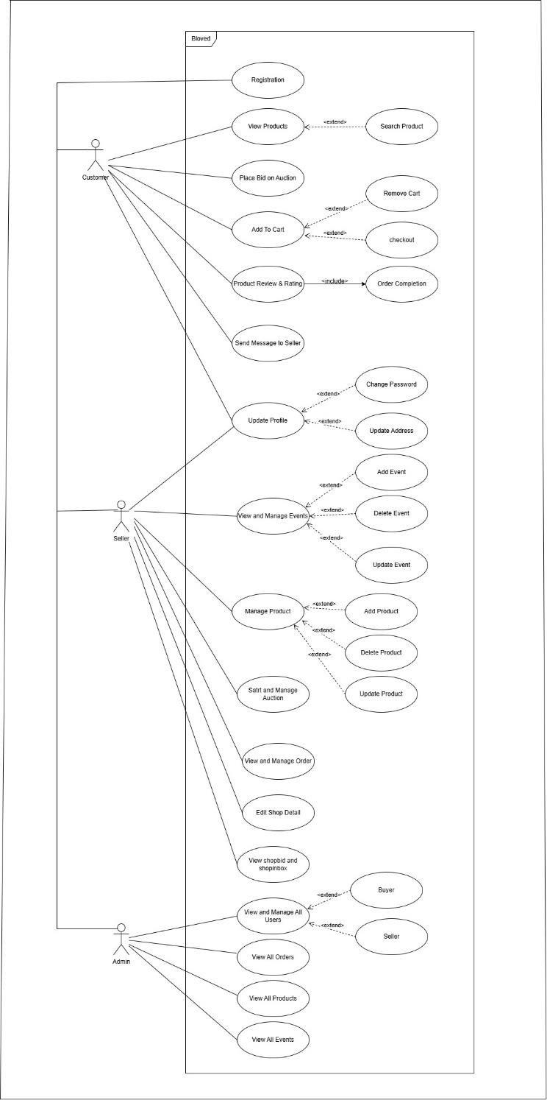

Figure 3

### Fully Dressed Use Cases

* + 1. **Login (Buyer, Seller, Admin)**

|  |  |  |  |
| --- | --- | --- | --- |
| **Identifier** | | Login(Buyer, Seller, Admin) | |
| **Purpose** | | Login to the system | |
| **Priority** | | High | |
| **Pre-conditions** | | User must enter his username and password | |
| **Post-conditions** | | User is logged in to the system | |
| **Typical Course of Action** | | | |
| **S#** | **Actor Action** | | **System Response** |
| **1** | Select login option from the header. | | Display login form. |
| **2** | Enter valid username and password. Press on “Login” button. | | Verifies the credentials and displays the homepage. |
| **3** | View the homepage. | | Allow the user to navigate through the site. |
| **Alternate Course of Action** | | | |
| **S#** | **Actor Action** | | **System Response** |
| **2a** | Enter invalid username and password. | | Display error message “Incorrect username or password”. |

* + 1. **Sign Up (Buyer, Seller, Admin)**

|  |  |  |  |
| --- | --- | --- | --- |
| **Identifier** | | Sign up (Buyer, Seller, Admin) | |
| **Purpose** | | Create a new account | |
| **Priority** | | High | |
| **Pre-conditions** | | User must have an email to sign up | |
| **Post-conditions** | | User has created a new account | |
| **Typical Course of Action** | | | |
| **S#** | **Actor Action** | | **System Response** |
| **1** | Select “Sign up” option. | | Display sign up form. |
| **2** | Enter all the fields. Click on “Sign up” button. | | Verifies the credentials and displays the homepage. |
| **Alternate Course of Action** | | | |
| **S#** | **Actor Action** | | **System Response** |
|  | None | | |

* + 1. **Browse Product or View Product (Buyer)**

|  |  |  |  |
| --- | --- | --- | --- |
| **Identifier** | | Browse Product (Buyer) | |
| **Purpose** | | View product quality and Order | |
| **Priority** | | Low | |
| **Pre-conditions** | | Users must select the product and category. | |
| **Post-conditions** | | The user has created a request to view the product category. | |
| **Typical Course of Action** | | | |
| **S#** | **Actor Action** | | **System Response** |
| **1** | The buyer requests to view the product in the product category. | | The system will display the product detail about products of selected  category. |

* + 1. **Search Product (Buyer)**

|  |  |  |  |
| --- | --- | --- | --- |
| **Identifier** | | Search Product (Buyer) | |
| **Purpose** | | Search product in website | |
| **Priority** | | Low | |
| **Pre-conditions** | | Users must select the search bar. | |
| **Post-conditions** | | User search for the product. | |
| **Typical Course of Action** | | | |
| **S#** | **Actor Action** | | **System Response** |
| **1** | The buyer requests to search the product in the product category. | | System will search products in the database and display information. |

* + 1. **Wishlist (Buyer)**

|  |  |
| --- | --- |
| **Identifier** | Manage Wishlist (Buyer) |
| **Purpose** | Product add in wishlist |

|  |  |  |  |
| --- | --- | --- | --- |
| **Priority** | | Moderate | |
| **Pre-conditions** | | User select the product. | |
| **Post-conditions** | | User add product in wishlist.. | |
| **Typical Course of Action** | | | |
| **S#** | **Actor Action** | | **System Response** |
| **1** | The buyer search the product in product catagory. | | The system will display the product. |
| **2** | The buyer add the product in wishlist. | | The system will display product added in wishlist. |
| **3** | The buyer can delete product in wishlist. | | The system will display product deleted in wishlist. |

* + 1. **Bid (Buyer)**

|  |  |  |  |
| --- | --- | --- | --- |
| **Identifier** | | Bid (Buyer) | |
| **Purpose** | | Negotiate Price | |
| **Priority** | | Moderate | |
| **Pre-conditions** | | User select the product and send bid to the seller. | |
| **Post-conditions** | | User wait the response of seller. | |
| **Typical Course of Action** | | | |
| **S#** | **Actor Action** | | **System Response** |
| **1** | The buyer select the product. | | The system will display product detail and price. |
| **2** | The buyer send bid to the seller. | | The system will display your bid is successfully sent. |

* + 1. **Buy Product (Buyer)**

|  |  |
| --- | --- |
| **Identifier** | Buy Product (Buyer) |
| **Purpose** | Buy Product |
| **Priority** | Moderate |
| **Pre-conditions** | User select the product and catagory. |
| **Post-conditions** | User buy the selected product. |
| **Typical Course of Action** | |

|  |  |  |
| --- | --- | --- |
| **S#** | **Actor Action** | **System Response** |
| **1** | The buyer select the product. | The system will display product detail and price. |
| **2** | The buyer buy the product. | The system will display the detail form. |
| **3** | The buyer fill the form. | The system will display your order detail successfully submitted. |

* + 1. **Feedback (Buyer)**

|  |  |  |  |
| --- | --- | --- | --- |
| **Identifier** | | Feedback (Buyer) | |
| **Purpose** | | Feedback | |
| **Priority** | | Low | |
| **Pre-conditions** | | User select the product and send feedback. | |
| **Post-conditions** | | User sent the feedback of product. | |
| **Typical Course of Action** | | | |
| **S#** | **Actor Action** | | **System Response** |
| **1** | The buyer select the product and send the feedback | | The system will display feedback submitted. |

* + 1. **Rating (Buyer)**

|  |  |  |  |
| --- | --- | --- | --- |
| **Identifier** | | Rating (Buyer) | |
| **Purpose** | | Rating | |
| **Priority** | | Low | |
| **Pre-conditions** | | User received the order and rate the product and seller. | |
| **Post-conditions** | | User check quality of product and give rating. | |
| **Typical Course of Action** | | | |
| **S#** | **Actor Action** | | **System Response** |
| **1** | The buyer received the order and give rating to seller and product . | | The system will display Rating submitted. |

* + 1. **Manage Product (Seller)**

|  |  |  |  |
| --- | --- | --- | --- |
| **Identifier** | | Manage Product (Seller) | |
| **Purpose** | | Manage Product | |
| **Priority** | | Moderate | |
| **Pre-conditions** | | Seller check the product quantity. | |
| **Post-conditions** | | Seller add/delete/update product.. | |
| **Typical Course of Action** | | | |
| **S#** | **Actor Action** | | **System Response** |
| **1** | The seller check the product quantity and demand of product. | | The system will display the product statistic.. |
| **2** | The seller add/ delete/ update the product according to requirement. | | The system will display added/ deleted/ update product successfully. |

* + 1. **Review Bid (Seller)**

|  |  |  |  |
| --- | --- | --- | --- |
| **Identifier** | | Review Bid (Seller) | |
| **Purpose** | | Review Bid | |
| **Priority** | | Moderate | |
| **Pre-conditions** | | Seller check the listed product and review bid. | |
| **Post-conditions** | | Seller will send message to the buyer best price bid. | |
| **Typical Course of Action** | | | |
| **S#** | **Actor Action** | | **System Response** |
| **1** | The seller check the listed product bid. | | The system will display the products biding statistic. |
| **2** | The seller will send message to the buyer best price bid. | | The system will display response send successful to the buyer. |

* + 1. **Add Product (Seller)**

|  |  |
| --- | --- |
| **Identifier** | Add Product (Seller ) |
| **Purpose** | Manage Product |
| **Priority** | Moderate |
| **Pre-conditions** | User must have registered as a seller. |
| **Post-conditions** | User add new/old product. |
| **Typical Course of Action** | |

|  |  |  |
| --- | --- | --- |
| **S#** | **Actor Action** | **System Response** |
| **1** | The seller select the category to add product. | The system will display the product added successfully. |

* + 1. **Manage Account (Admin)**

|  |  |  |  |
| --- | --- | --- | --- |
| **Identifier** | | Manage Account (Buyer, Seller ) | |
| **Purpose** | | Manage Account | |
| **Priority** | | Moderate | |
| **Pre-conditions** | | User select the account buyer or seller. | |
| **Post-conditions** | | User select the account . | |
| **Typical Course of Action** | | | |
| **S#** | **Actor Action** | | **System Response** |
| **1** | The Admin select the seller account and manage the product, product category and Ads. | | The system will display the seller account is selected. |
| **2** | The Admin select the buyer account and manage the report, feedback and post requirement. | | The system will display the buyer account is selected. |

# CChapter 4

## System Design

**Chapter 4:** System Design

System design is the process of defining the architecture, components, and functionalities of a software system. It outlines how the system will be built, deployed, and interact with users and other systems. It considers scalability, security, performance, and user experience.

### Architecture Diagram

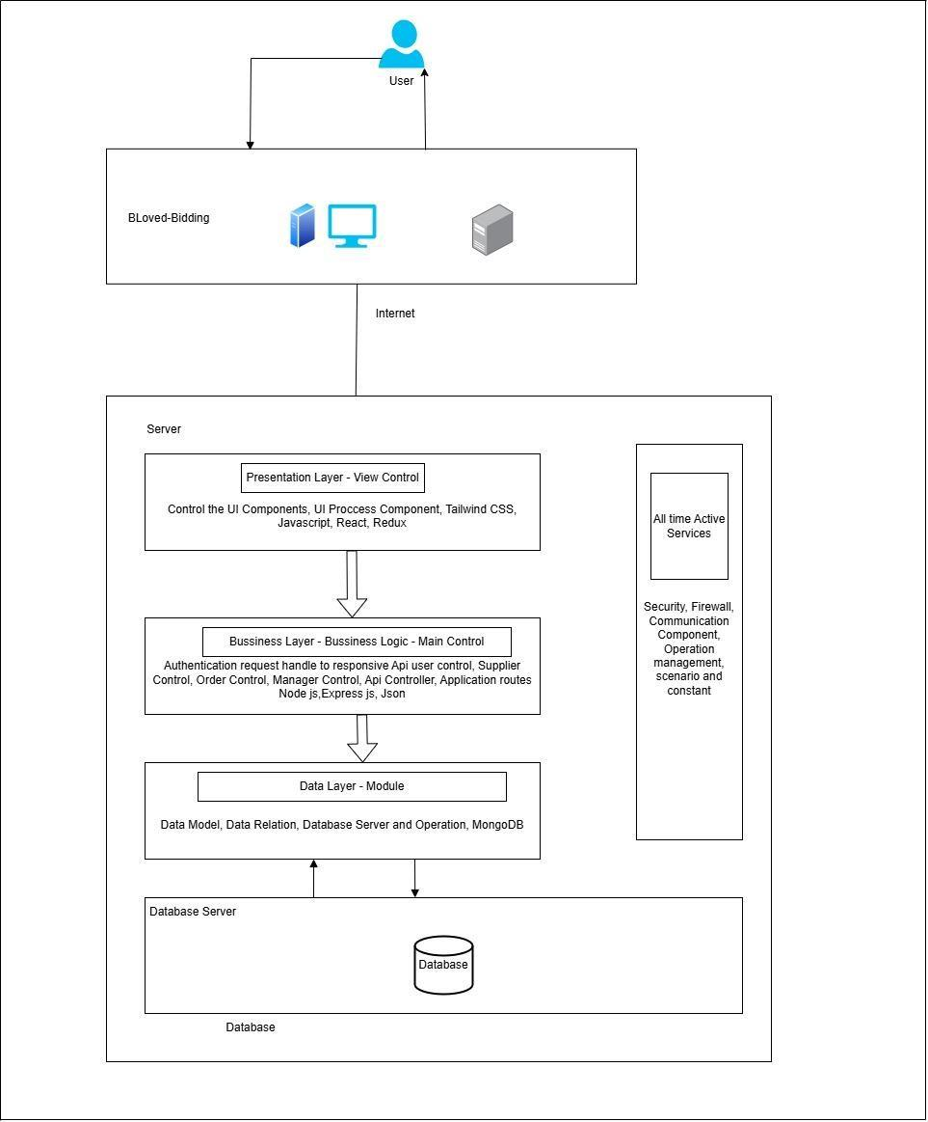

Figure 4

### Class Diagram

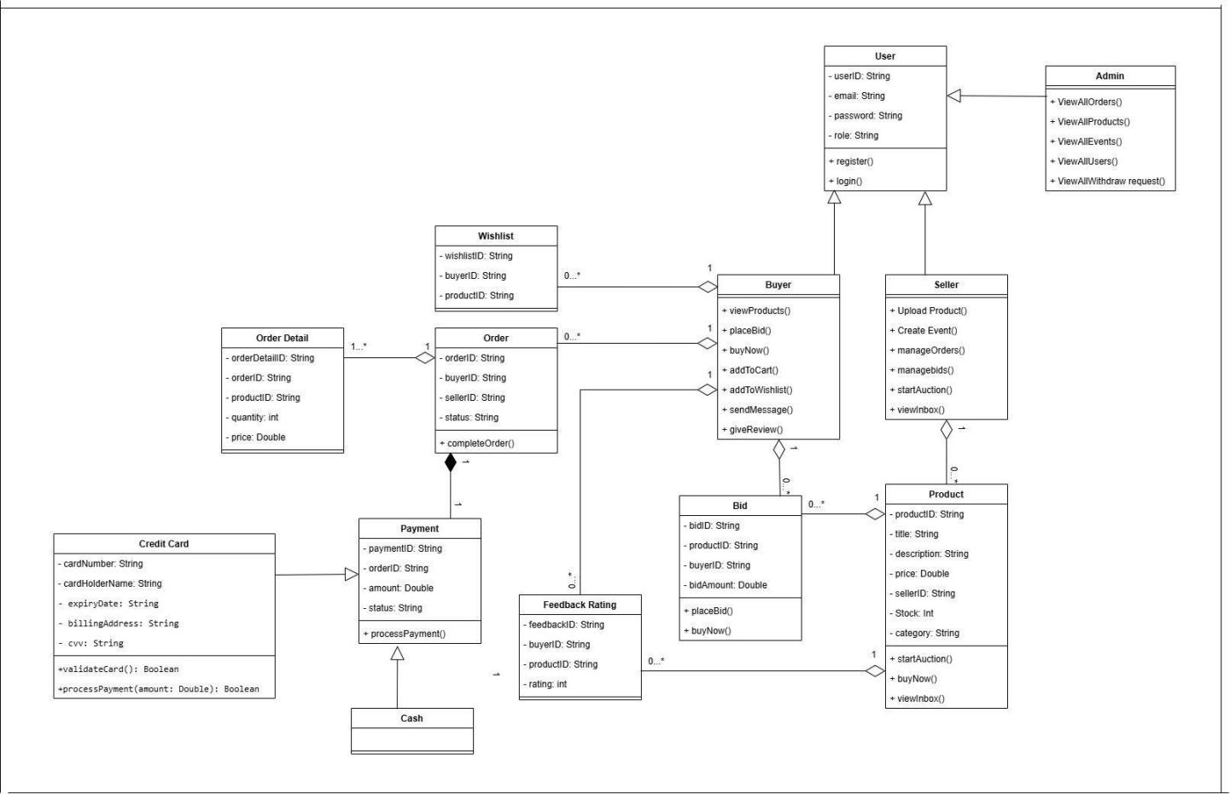

Figure 5

### Sequence / Collaboration Diagram

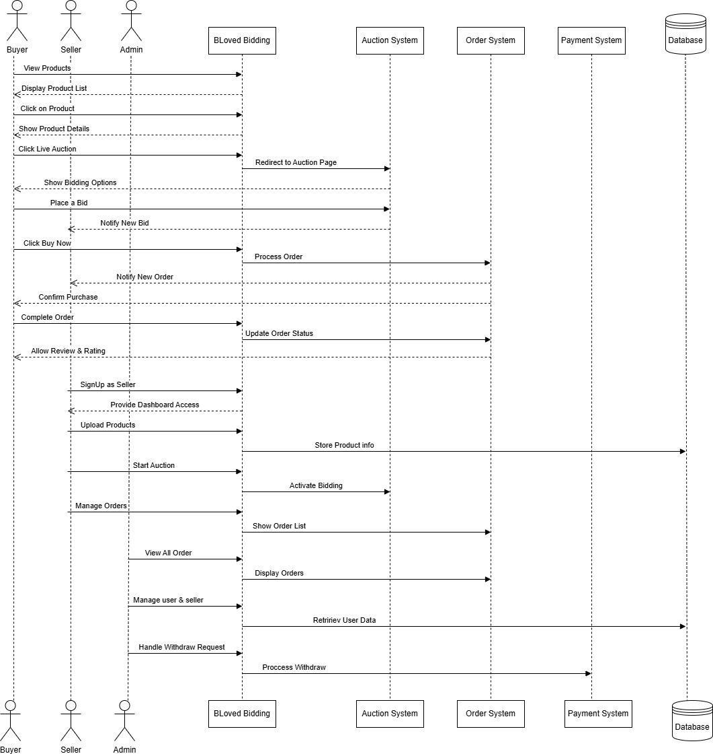

* 1. **Activity Diagram**
     1. **Activity Diagram (Buyer )**

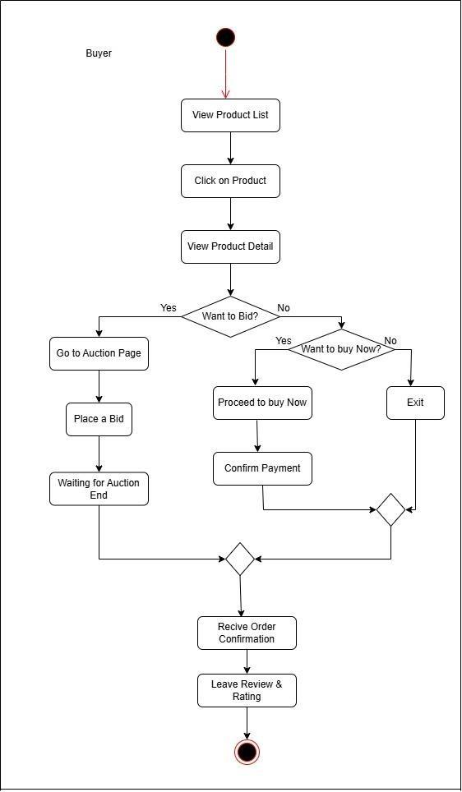

* + 1. **Activity Diagram Seller**

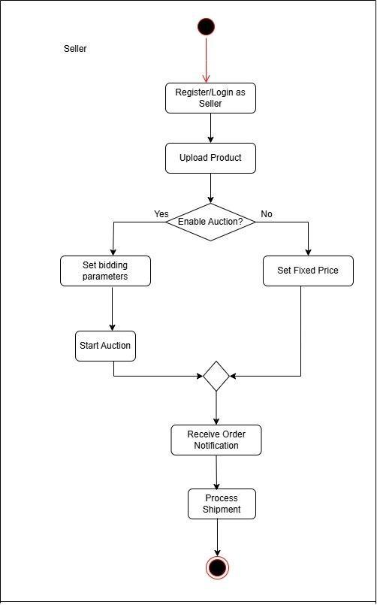

* + 1. **Activity Diagram (Admin)**

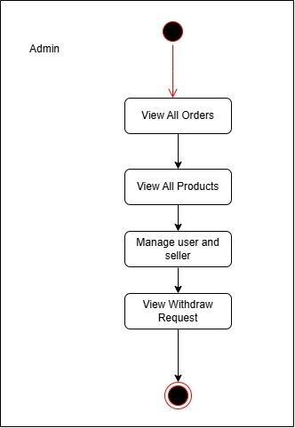

**Chapter 5/6**

**Implementation/Testing**

## 

**Chapter 5:** Implementation

The Implementation chapter of this project documentation provides a comprehensive overview of the practical steps taken to bring the project from concept to reality. It details the methodologies, technologies, and tools employed, as well as the development process, including coding practices and version control strategies. This chapter also outlines the integration of various components, ensuring a cohesive and functional system. Emphasis is placed on problem- solving techniques and the adaptations made in response to challenges encountered. By meticulously documenting the implementation phase, this chapter serves as a blueprint for understanding the project's construction and execution.

### Important Flow Control/Pseudo codes

FUNCTION PlaceBid(userID, productID, bidAmount)

GET product FROM Database using productID

GET currentDateTime

IF currentDateTime > product.AuctionEndTime THEN

RETURN Error "Auction has ended"

END IF

IF bidAmount <= product.CurrentHighestBid THEN

RETURN Error "Bid amount must be higher than current bid"

END IF

CREATE newBid object

SET newBid.User = userID

SET newBid.Amount = bidAmount

SET newBid.Time = currentDateTime

UPDATE product.CurrentHighestBid TO bidAmount

SAVE newBid TO Database

// Real-time update to other users

EMIT "NewBidPlaced" event TO all clients viewing productID

RETURN Success "Bid placed successfully"

END FUNCTION

**5.2. Components, Libraries, Web Services and stubs**

**Authentication:** Handles secure user login and registration screens to manage access control.

**User Management:** Allows users to upload, view, and manage their personal profiles and shop settings.

**Bidding System:** A dedicated module that enables users to place and manage bids on live auctions.

**Messaging System**: Facilitates real-time chat communication between buyers and sellers.

**5.3. Deployment Environment**

**Platform**: Web Application.

**Deployment Service:** AWS (Amazon Web Services) is used for hosting the application to ensure scalability and availability.

**Server Architecture:** The application utilizes a server-based architecture where a local server environment (Node.js) handles backend processes.

**5.4. Tools and Techniques**

**Frontend Development**: React and TailwindCSS were used for building a responsive and interactive user interface.

**Backend Development**: Express.js and Node.js were utilized to handle server-side logic and API routing.

**Database:** MongoDB was chosen as the database to store unstructured data such as product listings and user profiles.

**Development IDE:** Visual Studio Code was used as the primary Integrated Development Environment.

**5.5. Best Practices / Coding Standards**

**Responsive Design:** The application User Interface is designed to be user-friendly and responsive for both large screens and mobile devices.

**Asynchronous Operations:** All CRUD (Create, Read, Update, Delete) operations are performed using the Ajax method to prevent page refreshing and enhance user experience.

**Role-Based Access:** Each user is assigned specific roles and authorities, ensuring they work within their authorized workspace without interference.

**Performance Optimization:** The code is optimized for fast page rendering, ensuring pages load within seconds on a stable connection.

**5.6. Version Control**

Version control was managed using Git to track changes and collaborate effectively. The project repository is hosted on GitHub, allowing for secure code storage and history management. This ensures that all modifications to the source code are documented and allows for easy rollback to previous versions if necessary. The specific GitHub account associated with the project is "codewithnasir67".

### TestCases

**User SignUp:**

|  |  |
| --- | --- |
| **Test Case ID** | TC_BLB_01 |
| **Test Scenario** | Login |
| **Test Case description** | With Valid Data Set |
| **Steps to perform** | 1. Go Sign Up page 2. Enter Username: Nasir 3. Enter the Email: [testingyou9966@gmail.com](mailto:areditz884@gmail.com) 4. Enter Password: Nasir@1234 5. Click submit button |
| **Expected Result** | The system should send verification link in mail. |
| **Actual Result** | As expected, |
| **Test Status** | Pass |
| **Screen shot** |  |

|  |  |
| --- | --- |
|  |  |

**Login Shop**

|  |  |
| --- | --- |
| **Test Case ID** | TC_BLB_02 |
| **Test Scenario** | Login |
| **Test Case description** | With Valid Data Set |
| **Steps to perform** | 1. Go login page 2. Enter the Email: [testingyou9966@gmail.com](mailto:areditz884@gmail.com) 3. Enter Password: Nasir@1234 4. Click submit button |
| **Expected Result** | The system should go to the shop home page. |
| **Actual Result** | As expected, |
| **Test Status** | Pass |
| **Screen shot** |  |

|  |  |
| --- | --- |
|  |  |

|  |  |
| --- | --- |
| **Test Case ID** | TC_BLB_03 |
| **Test Scenario** | Register as a Seller |
| **Test Case description** | With Valid Data Set |
| **Steps to perform** | 1. Go Sign Up page 2. Enter Shop Name : My Shop 3. Enter Phone No: 03420855308 4. Enter the Email: [testingyou9966@gmail.com](mailto:areditz884@gmail.com) 5. Enter Address: Lahore 6. Enter ZipCode: 54000 7. Enter Password: Nasir@123 8. Click submit button |
| **Expected Result** | The system should send verification mail. |
| **Actual Result** | As expected, |
| **Test Status** | Pass |
| **Screen shot** |  |

|  |  |
| --- | --- |
|  |  |

|  |  |
| --- | --- |
| **Test Case ID** | TC_BLB_04 |
| **Test Scenario** | HomePage |
| **Test Case description** | With Valid Data Set |
| **Steps to perform** | 1. Go to Home-page 2. Click on home from header 3. Click on product and system will show all product. 4. User click on the Live Auction From navbar system will show all Auction Product (Mean all the product user can send bid). |
| **Expected Result** | The system should go to the home page. |
| **Actual Result** | As expected, |
| **Test Status** | Pass |
| **Screen shot** |  |

|  |  |
| --- | --- |
|  |  |

|  |  |
| --- | --- |
|  |  |

|  |  |
| --- | --- |
| **Test Case ID** | TC_BLB_05 |
| **Test Scenario** | User Profile |
| **Test Case description** | User profile Dashboard |
| **Steps to perform** | 1. Go to user profile and click on my bid page. 2. User must check the Accept or Reject bid my bid Page and Also receive a mail from seller. 3. User click on checkout button after accepting bid user go to checkout page. 4. User select payment method and click on submit button. |
| **Expected Result** | The system should go to the home page. |
| **Actual Result** | As expected, |
| **Test Status** | Pass |
| **Screen shot** |  |

|  |  |
| --- | --- |
|  |  |

|  |  |
| --- | --- |
|  |  |

|  |  |
| --- | --- |
| **Test Case ID** | TC_BLB_06 |
| **Test Scenario** | Seller Order Page |
| **Test Case description** | All Order Page |
| **Steps to perform** | 1. Seller view All order and Change the status of order. |
| **Expected Result** | The system should go to the All order page. |
| **Actual Result** | As expected, |
| **Test Status** | Pass |
| **Screen shot** |  |

|  |  |
| --- | --- |
| **Test Case ID** | TC_BLB_07 |
| **Test Scenario** | User Give Rating and Review |
| **Test Case description** | Order Received then give Rating and Review. |
| **Steps to perform** | 1. Go to product detail page Click submit button |
| **Expected Result** | The system should go to the home page. |
| **Actual Result** | As expected, |
| **Test Status** | Pass |
| **Screen shot** |  |

# **Chapter 7**

Summary, Conclusion and Future Enhancements

**Chapter 7:** Summary, Conclusion & Future Enhancements

## Project Summary

BLoved Bidding is a specialized online marketplace developed to facilitate the buying and selling of preloved items within Pakistan. The primary objective was to create a platform that eliminates intermediaries, allowing buyers and sellers to interact directly through features like live auctions and real-time bidding. Built using the MERN stack (MongoDB, Express, React, and Node.js), the application provides a responsive and secure environment for sustainable shopping. Key features include user authentication, product management, and an integrated messaging system to ensure a smooth and trusted user experience.

## Achievements and Improvements

The project successfully implemented a real-time bidding engine that allows users to compete fairly for products, a feature often missing in traditional classified platforms. Improvements were made over existing solutions like OLX.pk and Facebook Marketplace by focusing on curated quality, seller transparency via profiles, and integrated communication channels. We successfully verified core functionalities through rigorous testing, ensuring that the registration, bidding, and checkout processes work as expected.

## Critical Review

While the system is fully functional, the development process revealed several critical areas for consideration. Adopting and integrating the MERN stack required a significant learning curve, particularly in managing application states and database relationships. Currently, the system is optimized for a local server environment, and moving to a large-scale production environment would require further database tuning. Additionally, while security measures like password encryption are in place, the platform would benefit from more advanced automated dispute resolution tools.

## Lessons Learnt

This project provided invaluable experience in the complete Software Development Life Cycle (SDLC), particularly in requirement gathering and system design. We gained deep technical knowledge of full-stack JavaScript development and NoSQL database management. Key lessons included the importance of early prototyping and the necessity of user feedback in refining the interface. Furthermore, managing the project's timeline and documentation improved our professional communication and time-management skills.

## Future Enhancements/Recommendations

Future iterations of BLoved Bidding could include an AI-driven recommendation engine to personalize the shopping experience for users. Developing native mobile applications for Android and iOS would significantly increase accessibility for the Pakistani market. We also recommend integrating local and international payment gateways (such as Jazzcash, Bank transfer or EasyPaisa) to offer more flexible transaction options. Finally, implementing video-based live auctions and advanced image recognition could help in further verifying product authenticity and reducing misrepresentation.

# **Appendices**

**Appendix A: User Manual**

The User Manual provides a comprehensive guide for Buyers and Sellers to navigate the BLoved Bidding platform effectively. It details every step from initial account registration and profile setup to listing items for auction and participating in live bidding. This appendix serves as a visual and textual walkthrough to ensure that all users, regardless of technical skill level, can utilize the application’s features with ease.

* 1. **Getting Started**
     1. **Account Registration and Login**

To access the platform's features, users must first create an account by providing their name, email, and a secure password. Upon registration, the system sends a verification link to the registered email address to activate the account. Once verified, users can log in using their credentials to access their personalized dashboard.

**A.1.1.1 Managing Your Profile**

After logging in, users can navigate to the "Profile" section to update personal details, upload a profile picture, and manage contact information. This section also allows users to track their order history and view their active bids.

### **A.2. Core Marketplace Activities**

#### **A.2.1. Buying and Bidding**

Buyers can browse various categories such as clothing, shoes, and furniture to find preloved items. To purchase an item, users can either "Buy Now" for fixed-price products or participate in a "Live Auction" by entering a competitive bid amount.

#### **A.2.1.1. Checkout and Feedback**

Once a bid is accepted or an item is purchased, the buyer proceeds to the checkout page to select a payment method and provide a shipping address. After receiving the order, buyers are encouraged to leave a review and a star rating for the seller to maintain community trust.

**Appendix B: Administrator Manual**

The Administrator Manual is a technical resource designed for platform moderators to manage the backend operations of BLoved Bidding. It outlines the procedures for monitoring user activity, resolving disputes, and ensuring system stability. This manual is essential for maintaining a safe and efficient marketplace for all participants.

### **B.1. System Administration**

#### **B.1.1. User and Seller Moderation**

The administrator has the authority to view all registered buyer and seller accounts through the admin dashboard. If a user violates platform policies or is reported for fraudulent activity, the admin can suspend or permanently delete the account.

#### **B.1.1.1. Product and Event Oversight**

Admins can monitor all listed products and scheduled auction events to ensure they meet the platform's quality standards. The system provides tools to remove inappropriate listings and moderate live auctions if necessary.

### **B.2. Data and Performance Management**

#### **B.2.1. Database Backups and Security**

To prevent data loss, administrators must ensure that the MongoDB database is backed up daily. In the event of a server crash, these backups allow the system to be restored to its latest state. Admins also monitor security logs to protect the system from threats like SQL injection and XSS.

#### **B.2.1.1. Reporting and Analytics**

The admin dashboard includes features to generate reports on user activity, total sales, and system performance. These analytics help the administrator make informed decisions about future updates and marketing strategies.